- Model Description

Our model is a DDPM with UNet backbone for 28×28 RGB MNIST-like digits. We first use a Unet model with attention to learn feature and de-noise method in different steps in DDPM process. Then apply DDPM process with the trained model to generate MNIST-like digits from pure Gaussian noise.

- Architecture Overview
The base architecure follow Unet and built around residual blocks with GroupNorm and SiLU activation. The encoder progressively reduces spatial resolution while increasing channel capacity from 64 to 128 and then 256, reaching a bottleneck where both deep semantic processing and a 7×7 attention block operate. The decoder mirrors this process, restoring resolution while reducing channels and integrating skip connections to preserve spatial detail. A sinusoidal timestep embedding (256-dim) is injected into every residual block, enabling time-conditioned transformations essential for diffusion-based models. The design also supports an EMA (Exponential Moving Average) weight strategy to improve stability during sampling.
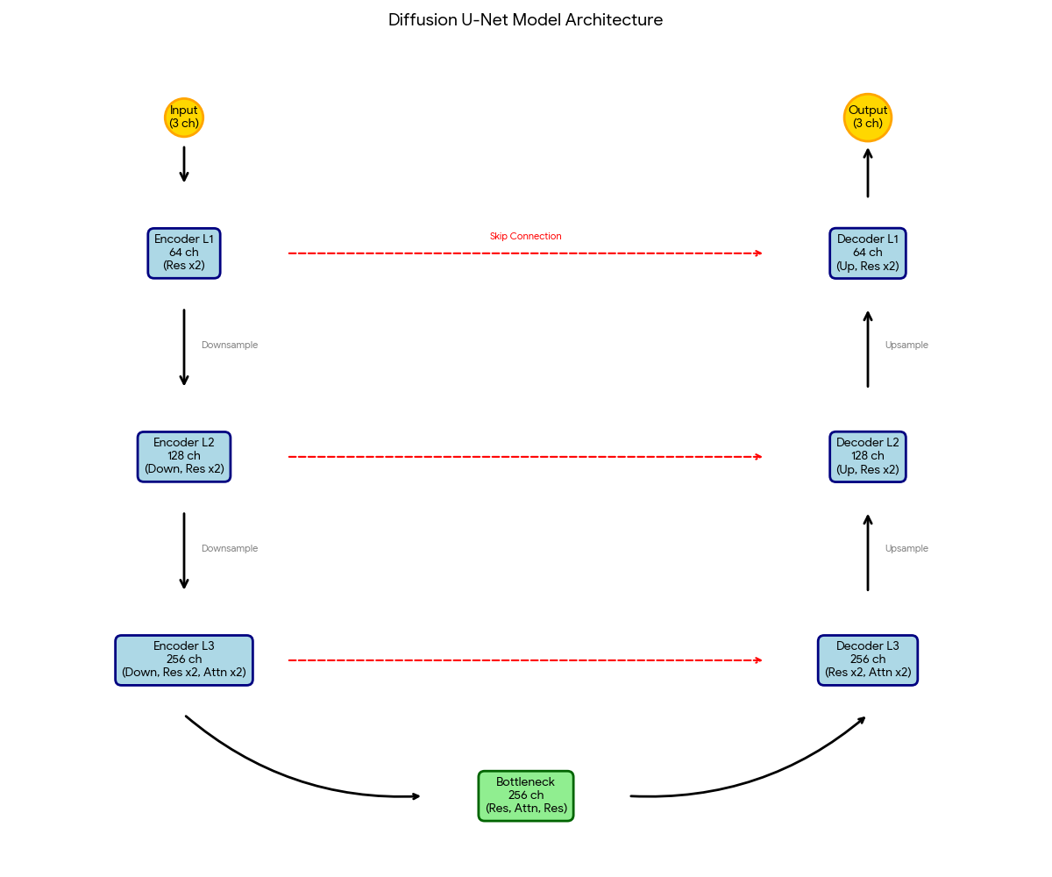

Figure1: Model diagram (generates with Gemini)

- Implementation Details

- Preprocessing & Augmentation
Dataset is MNIST-like written digits with 60k images, RGB converted
Augmentation: None, since the dataset feature is quite simple and is black and white photo.

- Model Setup
- Base channels: 64, channel_mults=(1,2,4), num_res_blocks=2, dropout 0.1, attention at 7×7.

- Training Setup
- Batch Size: 128
- Epochs: 50
- Optimizer:AdamW
- Learning Rate:2e-4
- Weight Decay 1e-4
- Loss: MSE loss
- Linear beta schedule (1e-4→2e-2) with T=1000.
- EMA: decay 0.999 on duplicate model.
- Checkpointing/logs: per-run timestamp directory; CSV loss log; periodic sample grids and diffusion-progress grids.
- Result Analysis
- Quantitative: TODO insert FID table (e.g., epoch vs FID vs notes).
- Qualitative: sample grids at milestones; note diversity/sharpness.
- Diffusion Process Visualizations: 8 samples × 7 checkpoints across timeline (include figure from sampling_progress_step_*.png).
- Ablations/observations: TODO (e.g., effect of EMA, batch size, schedule tweaks).
- Conclusion
- Recap training outcome (FID, visual quality), what worked best (e.g., EMA + grad clip), and brief next steps/improvements.

